**Name: ANIKET DEBNATH**

**ECE2017/100**

**ASSIGNMENT-4**

**Object Oriented Programming**

**EC-605A**

**1.Name different modeling diagrams in UML.**

UML is linked with **object oriented** design and analysis. UML makes the use of elements and forms associations between them to form diagrams. Diagrams in UML can be broadly classified as:

1. **Structural Diagrams –** Capture static aspects or structure of a system. Structural Diagrams include: Component Diagrams, Object Diagrams, Class Diagrams and Deployment Diagrams.
2. **Behavior Diagrams –** Capture dynamic aspects or behavior of the system. Behavior diagrams include: Use Case Diagrams, State Diagrams, Activity Diagrams and Interaction Diagrams.

The image below shows the hierarchy of diagrams according to UML 2.2

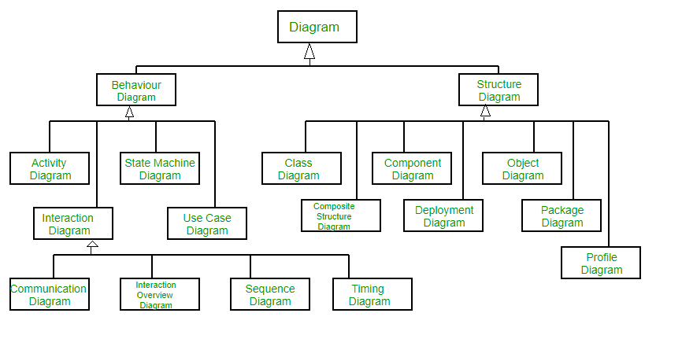

**Structural UML Diagrams –**

1. **Class Diagram –** The most widely use UML diagram is the class diagram. It is the building block of all object oriented software systems. We use class diagrams to depict the static structure of a system by showing system’s classes,their methods and attributes. Class diagrams also help us identify relationship between different classes or objects.
2. **Composite Structure Diagram –** We use composite structure diagrams to represent the internal structure of a class and its interaction points with other parts of the system. A composite structure diagram represents relationship between parts and their configuration which determine how the classifier (class, a component, or a deployment node) behaves. They represent internal structure of a structured classifier making the use of parts, ports, and connectors. We can also model collaborations using composite structure diagrams. They are similar to class diagrams except they represent individual parts in detail as compared to the entire class.
3. **Object Diagram –** An Object Diagram can be referred to as a screenshot of the instances in a system and the relationship that exists between them. Since object diagrams depict behaviour when objects have been instantiated, we are able to study the behaviour of the system at a particular instant. An object diagram is similar to a class diagram except it shows the instances of classes in the system. We depict actual classifiers and their relationships making the use of class diagrams. On the other hand, an Object Diagram represents specific instances of classes and relationships between them at a point of time.
4. **Component Diagram –** Component diagrams are used to represent the how the physical components in a system have been organized. We use them for modelling implementation details. Component Diagrams depict the structural relationship between software system elements and help us in understanding if functional requirements have been covered by planned development. Component Diagrams become essential to use when we design and build complex systems. Interfaces are used by components of the system to communicate with each other.
5. **Deployment Diagram –** Deployment Diagrams are used to represent system hardware and its software.It tells us what hardware components exist and what software components run on them.We illustrate system architecture as distribution of software artifacts over distributed targets. An artifact is the information that is generated by system software. They are primarily used when a software is being used, distributed or deployed over multiple machines with different configurations.
6. **Package Diagram –** We use Package Diagrams to depict how packages and their elements have been organized. A package diagram simply shows us the dependencies between different packages and internal composition of packages. Packages help us to organise UML diagrams into meaningful groups and make the diagram easy to understand. They are primarily used to organise class and use case diagrams.

**Behavior Diagrams –**

1. **State Machine Diagrams –** A state diagram is used to represent the condition of the system or part of the system at finite instances of time. It’s a behavioral diagram and it represents the behavior using finite state transitions. State diagrams are also referred to as **State machines** and **State-chart Diagrams**. These terms are often used interchangeably.So simply, a state diagram is used to model the dynamic behavior of a class in response to time and changing external stimuli.
2. **Activity Diagrams –** We use Activity Diagrams to illustrate the flow of control in a system. We can also use an activity diagram to refer to the steps involved in the execution of a use case. We model sequential and concurrent activities using activity diagrams. So, we basically depict workflows visually using an activity diagram.An activity diagram focuses on condition of flow and the sequence in which it happens. We describe or depict what causes a particular event using an activity diagram.
3. **Use Case Diagrams –** Use Case Diagrams are used to depict the functionality of a system or a part of a system. They are widely used to illustrate the functional requirements of the system and its interaction with external agents(actors). A use case is basically a diagram representing different scenarios where the system can be used. A use case diagram gives us a high level view of what the system or a part of the system does without going into implementation details.
4. **Sequence Diagram –** A sequence diagram simply depicts interaction between objects in a sequential order i.e. the order in which these interactions take place.We can also use the terms event diagrams or event scenarios to refer to a sequence diagram. Sequence diagrams describe how and in what order the objects in a system function. These diagrams are widely used by businessmen and software developers to document and understand requirements for new and existing systems.
5. **Communication Diagram –** A Communication Diagram(known as Collaboration Diagram in UML 1.x) is used to show sequenced messages exchanged between objects. A communication diagram focuses primarily on objects and their relationships. We can represent similar information using Sequence diagrams,however, communication diagrams represent objects and links in a free form.
6. **Timing Diagram –** Timing Diagram are a special form of Sequence diagrams which are used to depict the behavior of objects over a time frame. We use them to show time and duration constraints which govern changes in states and behavior of objects.
7. **Interaction Overview Diagram –** An Interaction Overview Diagram models a sequence of actions and helps us simplify complex interactions into simpler occurrences. It is a mixture of activity and sequence diagrams.

**2.Explain different components of a Use Case Diagram.**

# **UML Use Case Diagram**

A use case diagram is used to represent the dynamic behavior of a system. It encapsulates the system's functionality by incorporating use cases, actors, and their relationships. It models the tasks, services, and functions required by a system/subsystem of an application. It depicts the high-level functionality of a system and also tells how the user handles a system.

## **Purpose of Use Case Diagrams**

The main purpose of a use case diagram is to portray the dynamic aspect of a system. It accumulates the system's requirement, which includes both internal as well as external influences. It invokes persons, use cases, and several things that invoke the actors and elements accountable for the implementation of use case diagrams. It represents how an entity from the external environment can interact with a part of the system.

Following are the purposes of a use case diagram given below:

1. It gathers the system's needs.
2. It depicts the external view of the system.
3. It recognizes the internal as well as external factors that influence the system.
4. It represents the interaction between the actors.

## **How to draw a Use Case diagram?**

It is essential to analyze the whole system before starting with drawing a use case diagram, and then the system's functionalities are found. And once every single functionality is identified, they are then transformed into the use cases to be used in the use case diagram.

After that, we will enlist the actors that will interact with the system. The actors are the person or a thing that invokes the functionality of a system. It may be a system or a private entity, such that it requires an entity to be pertinent to the functionalities of the system to which it is going to interact.

Once both the actors and use cases are enlisted, the relation between the actor and use case/ system is inspected. It identifies the no of times an actor communicates with the system. Basically, an actor can interact multiple times with a use case or system at a particular instance of time.

Following are some rules that must be followed while drawing a use case diagram:

1. A pertinent and meaningful name should be assigned to the actor or a use case of a system.
2. The communication of an actor with a use case must be defined in an understandable way.
3. Specified notations to be used as and when required.
4. The most significant interactions should be represented among the multiple no of interactions between the use case and actors.

## **Example of a Use Case Diagram**

A use case diagram depicting the Online Shopping website is given below.

Here the Web Customer actor makes use of any online shopping website to purchase online. The top-level uses are as follows; View Items, Make Purchase, Checkout, Client Register. The **View Items** use case is utilized by the customer who searches and view products. The **Client Register** use case allows the customer to register itself with the website for availing gift vouchers, coupons, or getting a private sale invitation. It is to be noted that the **Checkout** is an included use case, which is part of **Making Purchase,** and it is not available by itself.

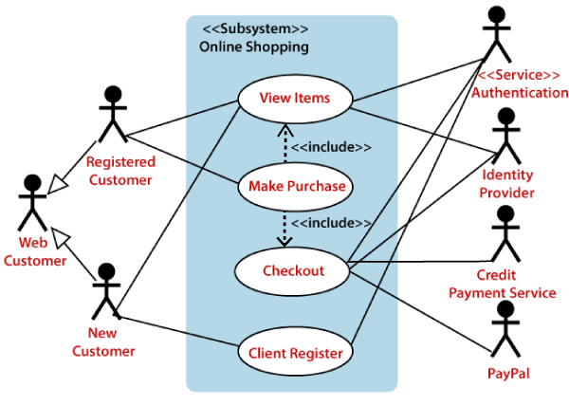

The **View Items** is further extended by several use cases such as; Search Items, Browse Items, View Recommended Items, Add to Shopping Cart, Add to Wish list. All of these extended use cases provide some functions to customers, which allows them to search for an item. The View Items is further extended by several use cases such as; Search Items, Browse Items, View Recommended Items, Add to Shopping Cart, Add to Wish list. All of these extended use cases provide some functions to customers, which allows them to search for an item.

Both **View Recommended Item** and **Add to Wish List** include the Customer Authentication use case, as they necessitate authenticated customers, and simultaneously item can be added to the shopping cart without any user authentication.

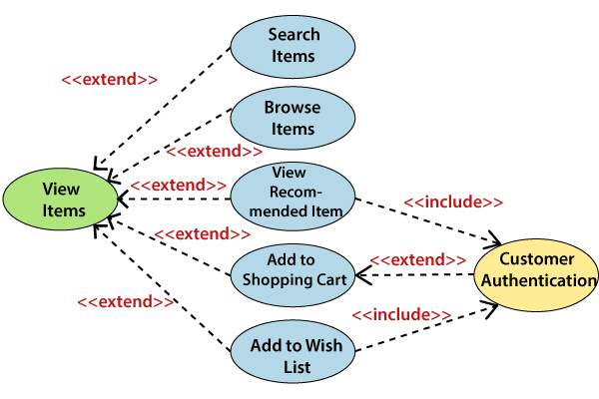

Similarly, the **Checkout** use case also includes the following use cases, as shown below. It requires an authenticated Web Customer, which can be done by login page, user authentication cookie ("Remember me"), or Single Sign-On (SSO). SSO needs an external identity provider's participation, while Web site authentication service is utilized in all these use cases.

The Checkout use case involves Payment use case that can be done either by the credit card and external credit payment services or with PayPal.

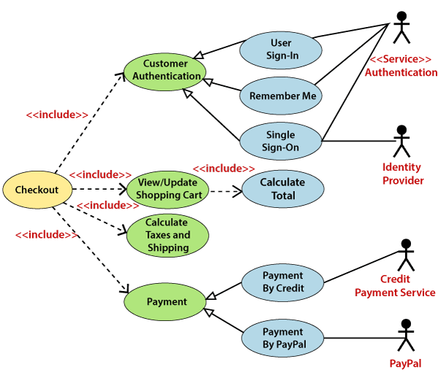

## **Important tips for drawing a Use Case diagram**

Following are some important tips that are to be kept in mind while drawing a use case diagram:

1. A simple and complete use case diagram should be articulated.
2. A use case diagram should represent the most significant interaction among the multiple interactions.
3. At least one module of a system should be represented by the use case diagram.
4. If the use case diagram is large and more complex, then it should be drawn more generalized.

**3.Draw a sequence diagram for Online Railway Ticket Reservation.**

**Sequence diagram for Online Railway Ticket Reservation** [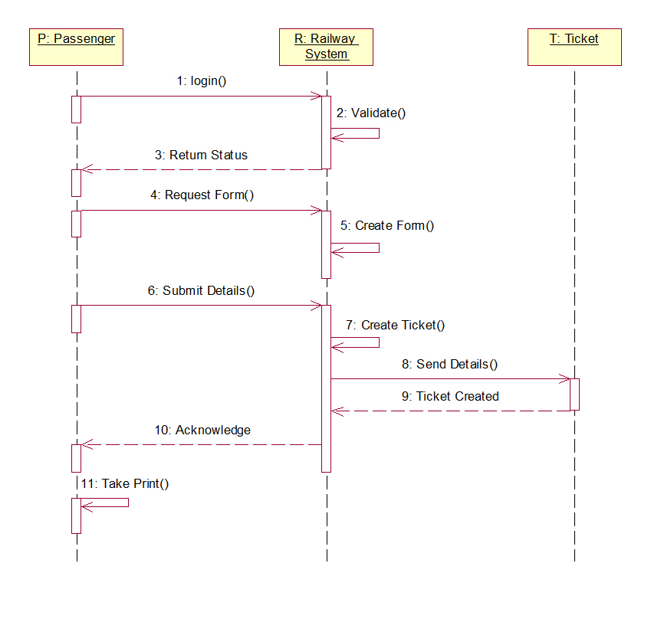](http://www.startertutorials.com/uml/wp-content/uploads/2013/10/RRS-Sequence-Diagram.jpg)

**4.Explain the use of Synchronization Bar in Activity Diagram with an example.**

##### **Synchronization**

A fork node is used to split a single incoming flow into multiple concurrent flows. It is represented as a straight, slightly thicker line in an activity diagram.

A join node joins multiple concurrent flows back into a single outgoing flow.

A fork and join mode used together are often referred to as synchronization.

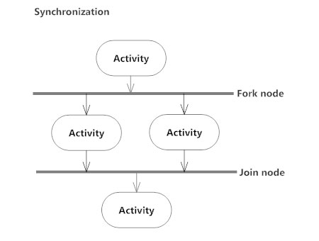

**5.Distinguish between Association, Aggregation and Generalization.**

# **Association, Composition and Aggregation in Java**

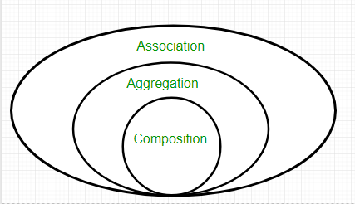

**Association**

Association is relation between two separate classes which establishes through their Objects. Association can be one-to-one, one-to-many, many-to-one, many-to-many.  
In Object-Oriented programming, an Object communicates to other Object to use functionality and services provided by that object. **Composition** and **Aggregation** are the two forms of association.

|  |
| --- |
| // Java program to illustrate the  // concept of Association  import java.io.*;    // class bank  class Bank  {      private String name;        // bank name      Bank(String name)      {          this.name = name;      }        public String getBankName()      {          return this.name;      }  }    // employee class  class Employee  {      private String name;        // employee name      Employee(String name)      {          this.name = name;      }        public String getEmployeeName()      {          return this.name;      }  }    // Association between both the  // classes in main method  class Association  {      public static void main (String[] args)      {          Bank bank = new Bank("Axis");          Employee emp = new Employee("Neha");            System.out.println(emp.getEmployeeName() +                 " is employee of " + bank.getBankName());      }  } |

Output:

Neha is employee of Axis

In above example two separate classes Bank and Employee are associated through their Objects. Bank can have many employees, So it is a one-to-many relationship.  
[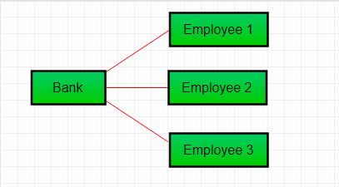](https://media.geeksforgeeks.org/wp-content/uploads/Aggre.png)

**Aggregation**

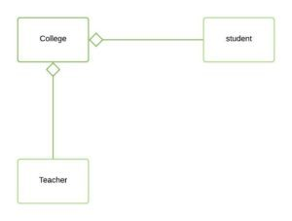

*Aggregation*

It is a special form of Association where:

* It represents **Has-A** relationship.
* It is a **unidirectional association** i.e. a one way relationship. For example, department can have students but vice versa is not possible and thus unidirectional in nature.
* In Aggregation,**both the entries can survive individually** which means ending one entity will not effect the other entity

|  |
| --- |
| // Java program to illustrate  //the concept of Aggregation.  import java.io.*;  import java.util.*;    // student class  class Student  {      String name;      int id ;      String dept;        Student(String name, int id, String dept)      {            this.name = name;          this.id = id;          this.dept = dept;        }  }    /* Department class contains list of student  Objects. It is associated with student  class through its Object(s). */  class Department  {        String name;      private List<Student> students;      Department(String name, List<Student> students)      {            this.name = name;          this.students = students;        }        public List<Student> getStudents()      {          return students;      }  }    /* Institute class contains list of Department  Objects. It is asoociated with Department  class through its Object(s).*/  class Institute  {        String instituteName;      private List<Department> departments;        Institute(String instituteName, List<Department> departments)      {          this.instituteName = instituteName;          this.departments = departments;      }        // count total students of all departments      // in a given institute      public int getTotalStudentsInInstitute()      {          int noOfStudents = 0;          List<Student> students;          for(Department dept : departments)          {              students = dept.getStudents();              for(Student s : students)              {                  noOfStudents++;              }          }          return noOfStudents;      }    }    // main method  class GFG  {      public static void main (String[] args)      {          Student s1 = new Student("Mia", 1, "CSE");          Student s2 = new Student("Priya", 2, "CSE");          Student s3 = new Student("John", 1, "EE");          Student s4 = new Student("Rahul", 2, "EE");            // making a List of          // CSE Students.          List <Student> cse_students = new ArrayList<Student>();          cse_students.add(s1);          cse_students.add(s2);            // making a List of          // EE Students          List <Student> ee_students = new ArrayList<Student>();          ee_students.add(s3);          ee_students.add(s4);            Department CSE = new Department("CSE", cse_students);          Department EE = new Department("EE", ee_students);            List <Department> departments = new ArrayList<Department>();          departments.add(CSE);          departments.add(EE);            // creating an instance of Institute.          Institute institute = new Institute("BITS", departments);            System.out.print("Total students in institute: ");          System.out.print(institute.getTotalStudentsInInstitute());      }  } |

Output:

Total students in institute: 4

In this example, there is an Institute which has no. of departments like CSE, EE. Every department has no. of students. So, we make a Institute class which has a reference to Object or no. of Objects (i.e. List of Objects) of the Department class. That means Institute class is associated with Department class through its Object(s). And Department class has also a reference to Object or Objects (i.e. List of Objects) of Student class means it is associated with Student class through its Object(s).  
It represents a **Has-A** relationship.  
[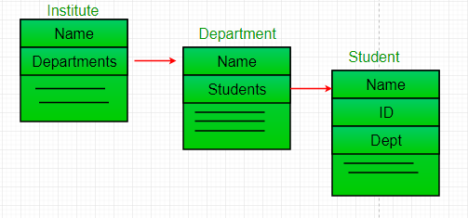](https://www.geeksforgeeks.org/media.geeksforgeeks.org/wp-content/uploads/Reference.png)

**When do we use Aggregation ??**  
Code reuse is best achieved by aggregation.

**Composition**

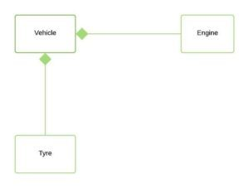

*Composition*

Composition is a restricted form of Aggregation in which two entities are highly dependent on each other.

* It represents **part-of** relationship.
* In composition, both the entities are dependent on each other.
* When there is a composition between two entities, the composed object **cannot exist** without the other entity.

Lets take example of**Library**.

|  |
| --- |
| // Java program to illustrate  // the concept of Composition  import java.io.*;  import java.util.*;    // class book  class Book  {        public String title;      public String author;        Book(String title, String author)      {            this.title = title;          this.author = author;      }  }    // Libary class contains  // list of books.  class Library  {        // reference to refer to list of books.      private final List<Book> books;        Library (List<Book> books)      {          this.books = books;      }        public List<Book> getTotalBooksInLibrary(){           return books;      }    }    // main method  class GFG  {      public static void main (String[] args)      {            // Creating the Objects of Book class.          Book b1 = new Book("EffectiveJ Java", "Joshua Bloch");          Book b2 = new Book("Thinking in Java", "Bruce Eckel");          Book b3 = new Book("Java: The Complete Reference", "Herbert Schildt");            // Creating the list which contains the          // no. of books.          List<Book> books = new ArrayList<Book>();          books.add(b1);          books.add(b2);          books.add(b3);            Library library = new Library(books);            List<Book> bks = library.getTotalBooksInLibrary();          for(Book bk : bks){                System.out.println("Title : " + bk.title + " and "              +" Author : " + bk.author);          }      }  } |

Output

Title : EffectiveJ Java and Author : Joshua Bloch

Title : Thinking in Java and Author : Bruce Eckel

Title : Java: The Complete Reference and Author : Herbert Schildt

In above example a library can have no. of **books** on same or different subjects. So, If Library gets destroyed then All books within that particular library will be destroyed. i.e. book can not exist without library. That’s why it is composition.

**Aggregation vs Composition**

1. **Dependency:** Aggregation implies a relationship where the child **can exist independently** of the parent. For example, Bank and Employee, delete the Bank and the Employee still exist. whereas Composition implies a relationship where the child **cannot exist independent** of the parent. Example: Human and heart, heart don’t exist separate to a Human
2. **Type of Relationship:** Aggregation relation is **“has-a”** and composition is **“part-of”** relation.
3. **Type of association:**Composition is a **strong** Association whereas Aggregation is a **weak** Association.

|  |
| --- |
| // Java program to illustrate the  // difference between Aggregation  // Composition.    import java.io.*;    // Engine class which will  // be used by car. so 'Car'  // class will have a field  // of Engine type.  class Engine  {      // starting an engine.      public void work()      {            System.out.println("Engine of car has been started ");        }    }    // Engine class  final class Car  {        // For a car to move,      // it need to have a engine.      private final Engine engine; // Composition      //private Engine engine;     // Aggregation        Car(Engine engine)      {          this.engine = engine;      }        // car start moving by starting engine      public void move()      {            //if(engine != null)          {              engine.work();              System.out.println("Car is moving ");          }      }  }    class GFG  {      public static void main (String[] args)      {            // making an engine by creating          // an instance of Engine class.          Engine engine = new Engine();            // Making a car with engine.          // so we are passing a engine          // instance as an argument while          // creating instace of Car.          Car car = new Car(engine);          car.move();        }  } |

Output:

Engine of car has been started

Car is moving

In case of aggregation, the Car also performs its functions through an Engine. but the Engine is not always an internal part of the Car. An engine can be swapped out or even can be removed from the car. That’ why we make The Engine type field non-final.

**6.Explain the use of component and deployment diagram.**

# **UML Deployment Diagram**

The deployment diagram visualizes the physical hardware on which the software will be deployed. It portrays the static deployment view of a system. It involves the nodes and their relationships.

It ascertains how software is deployed on the hardware. It maps the software architecture created in design to the physical system architecture, where the software will be executed as a node. Since it involves many nodes, the relationship is shown by utilizing communication paths.

## **Purpose of Deployment Diagram**

The main purpose of the deployment diagram is to represent how software is installed on the hardware component. It depicts in what manner a software interacts with hardware to perform its execution.

Both the deployment diagram and the component diagram are closely interrelated to each other as they focus on software and hardware components. The component diagram represents the components of a system, whereas the deployment diagram describes how they are actually deployed on the hardware.

The deployment diagram does not focus on the logical components of the system, but it put its attention on the hardware topology.

Following are the purposes of deployment diagram enlisted below:

1. To envision the hardware topology of the system.
2. To represent the hardware components on which the software components are installed.
3. To describe the processing of nodes at the runtime.

## **Symbol and notation of Deployment diagram**

The deployment diagram consist of the following notations:

1. A component
2. An artifact
3. An interface
4. A node

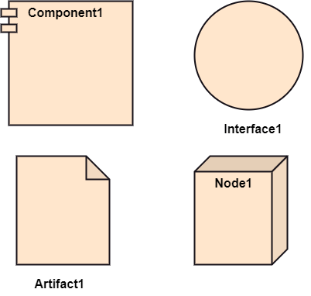

## **How to draw a Deployment Diagram?**

The deployment diagram portrays the deployment view of the system. It helps in visualizing the topological view of a system. It incorporates nodes, which are physical hardware. The nodes are used to execute the artifacts. The instances of artifacts can be deployed on the instances of nodes.

Since it plays a critical role during the administrative process, it involves the following parameters:

1. High performance
2. Scalability
3. Maintainability
4. Portability
5. Easily understandable

One of the essential elements of the deployment diagram is the nodes and artifacts. So it is necessary to identify all of the nodes and the relationship between them. It becomes easier to develop a deployment diagram if all of the nodes, artifacts, and their relationship is already known.

## **Example of a Deployment diagram**

A deployment diagram for the Apple iTunes application is given below.

The iTunes setup can be downloaded from the iTunes website, and also it can be installed on the home computer. Once the installation and the registration are done, iTunes application can easily interconnect with the Apple iTunes store. Users can purchase and download music, video, TV serials, etc. and cache it in the media library.

Devices like Apple iPod Touch and Apple iPhone can update its own media library from the computer with iTunes with the help of USB or simply by downloading media directly from the Apple iTunes store using wireless protocols, for example; Wi-Fi, 3G, or EDGE.

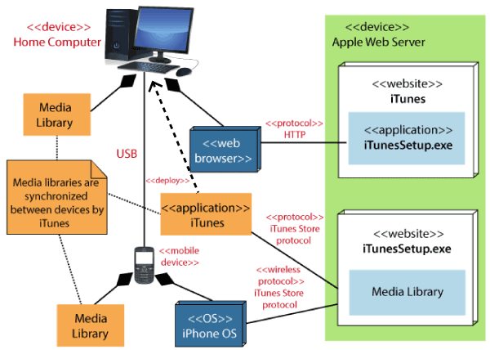

## **When to use a Deployment Diagram?**

The deployment diagram is mostly employed by network engineers, system administrators, etc. with the purpose of representing the deployment of software on the hardware system. It envisions the interaction of the software with the hardware to accomplish the execution. The selected hardware must be of good quality so that the software can work more efficiently at a faster rate by producing accurate results in no time.

The software applications are quite complex these days, as they are standalone, distributed, web-based, etc. So, it is very necessary to design efficient software.

Deployment diagrams can be used for the followings:

1. To model the network and hardware topology of a system.
2. To model the distributed networks and systems.
3. Implement forwarding and reverse engineering processes.
4. To model the hardware details for a client/server system.
5. For modeling the embedded system.